10 Mart 2016 tarihinden itibaren ise sadece aşağıda isimleri ve şube bilgileri kayıtlı şirketler aracılığıyla vize müracaatı kabul edilecektir.

كما أنه سوف يتم إستقبال الطلبات عن طريق الشركات فقط وفروعها المدرج أسماؤهم ومعلوماتهم أدناه إعتباراً من تاريخ 10 مارس/آذار 2016

Visa applications will only be received via these accredited companies starting from 10 March 2016.

--------------------------------------------------------------------------------------------

ŞİRKETLERİN ŞUBE LİSTESİ

BRANCH LIST OF COMPANIES

قائمة فروع الشركات



|  |  |  |
| --- | --- | --- |
| **NO** | **OFFICES** | **Address** |
| 1 | **RIYADH** | Dove Plaza (Hyper Panda), Umm Al Hamam Street, Riyadh,  Tel : 011 281 2930 Mob: 0550631468 |
| 2 | **JEDDAH** | Al Etimad Visa Centre - TasHeel Commercial Plaza - Ground Floor - Suwaid Bin Sakher Street, Off Jundub Bin Kaab Street (Off Prince Sultan Street), Al Mohammadiyah District 1, Jeddah, Tel : 012 611 7381 Mob: 0541586373 |
| 3 | **AL KHOBAR** | Ground Floor, Unified Visa Application Centre, King Faisal Road, Al Rakah Al Janubiyah Dist, Al Khobar, K.S.A.  Tel : 013 841 0593 Mob: 0569924293 |
| 4 | **YANBU** | Shop No.3,Opp. To El-Faleh Sports House, Hijji Center, King Abdul-Aziz  Street, Yanbu, K.S.A.  Tel : 014 322 7598 Mob: 0549066200 |
| 5 | **JUBAIL** | Ground Floor, Al Khater Business Center 2, Al Madinah Al Munawara St., Jubail, K.S.A. Tel : 013 361 3295 Mob: 0547388550 |
| 6 | **BURAIDAH** | Shop No 29. Opposite to Jawazath, 40th Street, Buraidah, KSA  Tel : 016 326 9886 Mob: 0543649768 |
| 7 | **KHAMIS MUSHAYT** | King Saud Street, Cross with Umsarar Road, Near Burqan Fuel Station, Umsarar Dist. Khamis Mushayt, Tel : 017 237 0153 Mob: 0543649768 |
| 8 | **HAIL** | Ground Floor, Near Tahaweel Al Rajhi Bank, King Khalid Road, HAIL, KSA.  Mob : 0530372172 |



|  |  |  |
| --- | --- | --- |
| **NO** | **OFFICES** | **Address** |
| 1 | **RIYADH** | Visa Division - AlMasarah Center- Prince Sultan Street – Takhasusi Qt. – Riyadh Phone No; 0112167736 ex 236 or 222 Mobile; 0544054219 – 0502844611 |
| 2 |  | King Fahad Road Branch – Olaya Qtr. – AlFursan Bulding  Phone . 0112931160 ex111 Mobile. 0544053227 |
| 3 |  | AlMathar Branch – Makkah Road – Northern Mathar Qt.- Riyadh  Phone; 0118801100 ex 106 or 103 Mobile. 0505455025 – 0558012255 |
| 4 |  | Rowdah Branch – Rowdah2 Qt. – AlHassan Bin Ali St. - Riyadh  Phone; 0114454166 Mobile no. 0508898778 |
| 5 |  | Rabwah Branch – Rabwah Qt. –onaizah St – Riyadh  Phone No, 114911645 Mobile No. 546043427 |
| 6 |  | Rawdah 2 Branch –Rawdah2 Qt. – Airport Rd - Exit11  Phone . 0112545181 Mobile . 0551610750 |
| 7 | **JEDDAH** | Fursan travel – Jamjoom Center – Palastine Street – Jeddah – Western province -  Phone . 012-6615332 Mobile No. 0542616742 |
| 8 | **BURAIDAH** | Fursan Travel – Omar Bin Alkhatab St – Buraidah –  Phone ; 0163826471 Mobile No. 0566223785 |
| 9 | **KHOBAR** | Fursan travel - king Abdulaziz Street – AlKhubar – eastern province  Phone. 013-8262224- Mobile: 0562030077 |
| 10 | **QASSIM** | Fursan travel- King Khalid St. – Qassim –  Phone . 016-3248020 Mobile . 0553415867 |
| 11 | **HAİL** | Fursan Travel - King Abdullah Rd- Northern Province-  Phone; 0165325623 Mobile ; 0505740998 |
| 12 | **TABUK** | Fursa Travel -KING ABDULLAH ROD – Tabuk –  Phone ; 0144214254 Mobile No ; 0544055144 |
| 13 | **ABHA** | Fursan travel –AlKhalidiah Qt –Abu Hurairah St.–Abha –Southern Province  Phone; 0172313335 mobile no. 0555757262 |
| 14 | **GAZAN** | Fursan travel –Almutala St – Adnan otel - Gazan –  Phone 0172300008 - Mobile ; 0566639997 |
| 15 | **MADDINAH** | Fursan Travel – Sultanah Qt – Madinah Munawarah –  Phone; 0148159081 Mobile; 0506033955 |
| 16 | **MAKKAH** | Fursan Travel - Alnoor Hospital – Om Aljood St - Saudi Arbaia  Mobile; 0530929680 |
| 17 | **KHAMEES MUSHAİT** | Fursan travel –King Abdulaziz St – Alanahdah Qt – Front of Rajhi Bank  Phone; 0172300007 Mobile ; 0552935127 |
| 18 | **WADİ ALDAWASER** | Fursan travel- High way Rd – Wadi AlDawaser-  Phone; 0117848845 Mobile. 0530435206 |
| 19 | **HAWTAT BANİ TAMEEM** | Fursan Travel – Prince Sultan St- Hawat Bani tamim –  Phone ; 0115552424 - Mobile ; 0555101082 |
| 20 | **KHARJ** | Fursan Travel – Kharj – Suaid Arabia  Phone; 0115443300 Mobile No. 0509895266 |
| 21 | **YANBU** | Fursan travel – Yanbu General Hospital – Yanbu –  Phone; 0143907478 Mobile; 050603395 |

* [Home](http://www.attartravel.com/#home)
* [Packages](http://www.attartravel.com/#packages)
* [About Us](http://www.attartravel.com/#history)
* [Contact Us](http://www.attartravel.com/#contactus)
* [Branches](http://www.attartravel.com/#contactus)
* [العربية](http://www.attartravel.com/home/changeSiteLang/ar)

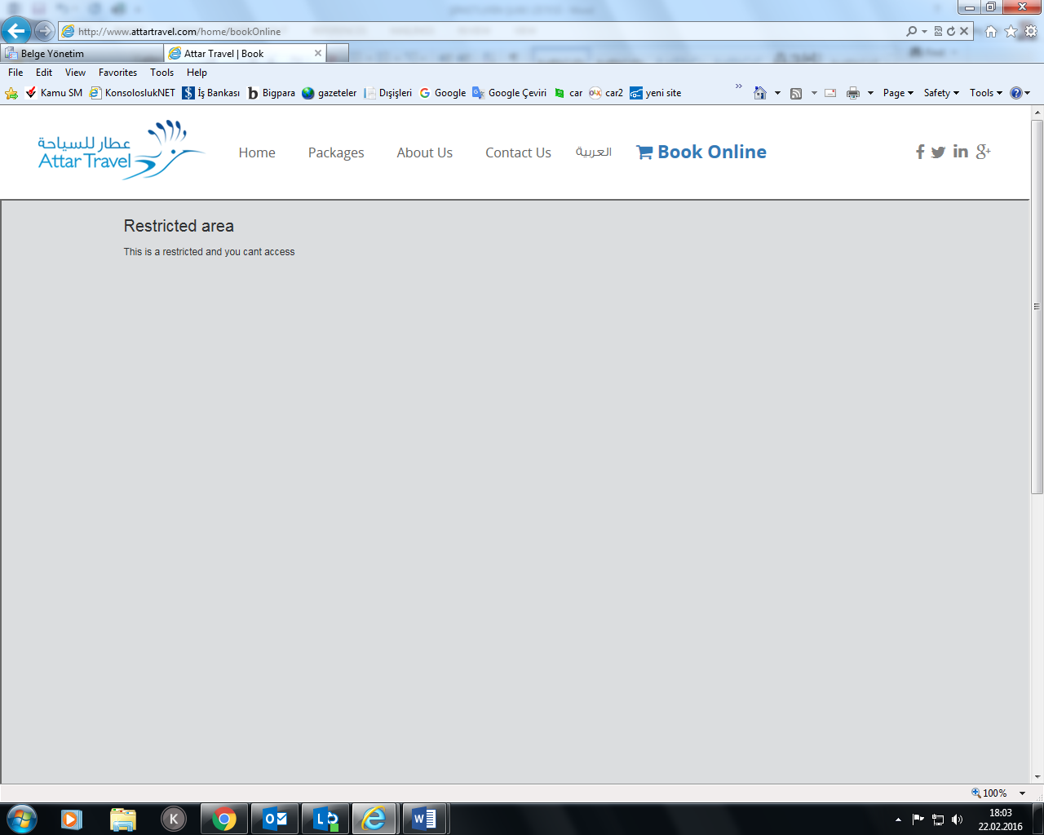

|  |  |  |
| --- | --- | --- |
| **NO** | **OFFICES** | **Address** |
| 1 | **RIYADH** | Attar Travel Khaledia Business Centre Olaya Main Street-Olaya, PO Box 364, Riyadh 11411Tel +966 11 4648452 / 4658495 Fax +966 11 2791830 |
| 2 |  | Attar Travel Travel Management Center4, South Block, Mezzanine Abraj Atta’awuneya PO Box 364 King Fahd Road, OlayaTel +966 11 218 1110 |
| 3 |  | Attar Travel Business gate complex Airport rd. PO Box 364, Riyadh 11411Tel +966 11 2030402 / 2032744 Fax +966 11 2030779 |
| 4 |  | Attar Travel Batha Tel +966 11 4094244 / 01 4090988 Fax +966 11 40433099 |
| 5 |  | Attar Holidays Khaledia Business Centre, Olaya Main Street-OlayaPO Box 364, Riyadh 11411Tel +966 11 4620659 / 4647260 Fax +966 11 217855 |
| 6 | **BURAIDAH** | Attar TravelAl Khubaib Street, PO Box 23145 Buraidah 51311 Tel +966 16 325 1343 / 324 5047 Fax +966 16 325 1017 |
| 7 | **JEDDAH** | Main Office JEDDAH Attar Travel King Abdul Aziz Street BaladPO Box 439 Jeddah 21411Tel +966 12 647 2060 / 647 6406 647 6021 / 648 2263Fax +966 2 647 3258 |
| 8 |  | Attar Travel Sharafiya, Seteen Street.Tel +966 12 6453158 / 6453164 / 6453127 Fax +966 12 6453127 |
| 9 |  | Attar Travel Prince Sultan Street. Tel +966 12 2882737 Fax +966 12 2751262 |
| 10 |  | Attar Holidays Holiday Center SKAB Center Madina Road PO Box 18600 Jeddah 21425Tel +966 12 660 0817/665 4287 Fax +966 12 664 0666 |
| 11 |  | Al Tahlia Street Beside Ahly Club Tel +966 12 6700767Fax +966 12 6709166 |
| 12 |  | Business Travel Center SKAB Center, Madina RoadPO Box 18600 Jeddah 21425Tel +966 12 660 2323 / 665 7879 Fax +966 12 667 3576 |
| 13 |  | Attar Travel Hay ElSafa, Abd Allah Sharbatly Street. Tel +966 12 2718014 Fax +966 12 2718015 |
| 14 |  | Attar Travel Industrial Zone, First AreaTel +966 12 6353890/6354168 |
| 15 | **MADINAH** | MADINA Attar Travel Madina Commercial Center, Siteen Street PO Box 6868 Madina Al-MunawaraTel +966 14 836 8644 / 836 7051Fax +966 14 836 0897 |
| 16 | **KHAMIS MUSHAYT** | Attar TravelBindajem Building, Main Street PO Box 891Khamis MushaytTel +966 17 223 4772 223 5614 / 222 0176 / 222 0180 Fax +966 17 222 1120 |
| 17 | **TAIF** | Attar TravelAl Rayyan Center, Abubacker Siddiq Street PO Box 1382 – TaifTel +966 12 733 4120 / 733 5790738 0709 / 732 0550Fax +966 12 733 5666 |
| 18 | **AL RONA** | Attar TravelAl Rona Military, City RoadPO Box 891 Khamis MushaytTel +966 17 250 1179/250 0728 Fax +966 17 250 0728 |
| 19 | **YANBU** | Attar Travel Royal Commission Business Travel Center, Al Nawa Center P.O Box 30145 Yanbu Al SiniayahTel +966 14 321 0100Fax +966 14 396 0067 |
| 20 | **KHOBAR** | Saddik and Mohd Attar Co. King Abdel Azizi St25th cross AlShamalia Tel: +966 013 8674050 / 8675693 / 867 4822 / 867 8500 Fax : +966 013 867 9255 |
| 21 | **DAMMAM** | DammamAttar TravelKing Saud St, AlDawasirTel: +966 013 834 1222/ 835 4363 Fax:+966 013 834 1843 |

**[](http://alfifa.com/)**

|  |  |  |  |
| --- | --- | --- | --- |
| **NO** | **OFFICES** | **Address** | **Location Map** |
| 1 | Dammam application center | Muhammed Ibn Saud, Ad Dammam 32241 5579, | <https://goo.gl/j4gMo3> |
| 2 | Dammam Branch | Ibn ishaq ,st | <https://goo.gl/QpB0tJ> |
| 3 | Hassa Branch | KING ABDUAZIZRD , ALHOFUF. | <https://goo.gl/DlHlIO> |
| 4 | Jeddah Branch | Al-sharafeyah jeddah. | <https://goo.gl/3rV8cs> |
| 5 | Jubail Branch | King Fahd way , Jubail. | <https://goo.gl/74OXDO> |
| 6 | Khobar Branch | Alamir turky , alkornish alkhober. | <https://goo.gl/lLbGOL> |
| 7 | Raka Application center, | Mohammed alfateh street ,alkhobar. | <https://goo.gl/Ngj9a8> |
| 8 | Riyadh Application Center | 6507 Umm Al Hamam, Ash Sharqi, Riyadh 12321 4621. | <https://goo.gl/9nd40H> |
| 9 | Saudi Aramco Dharan (Employees Only) | Medra Tower Ground Floor, Dhaharn | <https://goo.gl/so9O0o> |
| 10 | Sabic Jubail (Employees Only) | Sabic Headoffice, Fanateer Juabail | <https://goo.gl/3r7sSl> |
| 11 | Sadara Dhaharn (employees Only) | Al Turki Business Cenetr Vila 3 | <https://goo.gl/8XhqdI> |

***Amaani Global  
Visa Services***

|  |  |  |
| --- | --- | --- |
| **NO** | **OFFICES** | **Address** |
| 1 | **RIYADH** | Building 14, Office 8, Ground Floor, Askaan Mather (kuwaiti Askaan) Prince Mansoor bin Abdulaziz St. Olaya Riyadh Kingdom of . Tel: 011 2192260, Mob: 0501060686, Mob: 0571161020 |
| 2 | **JEDDAH** | Madinah Road, Hayat Center, beside Raddison Sas Hotel ,1st floor  Contact Person: Ibrahim : 0544344384 |
| 3 | **DAMMAM** | Nayef street intersection with 20th St, Khobar  Contact Person: Ali : 0599996916 |

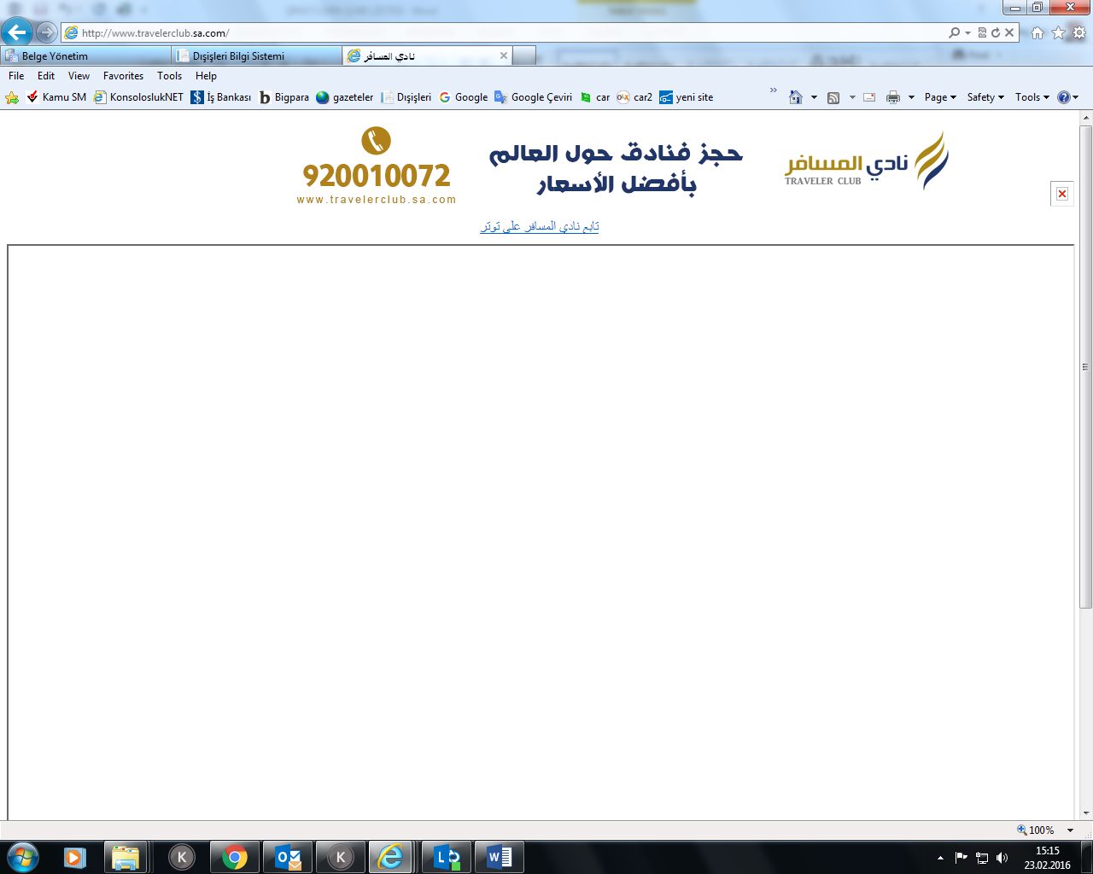

|  |  |  |
| --- | --- | --- |
| **NO** | **OFFICES** | **Address** |
| 1 | **RIYADH** | King Abdulaziz Road Al Morouj District Exit 5, Near to Rooms by Almutlaq Riyadh, Tel: 920010072 Fax: 011 2015995 |
| 2 |  | Al Oroubah Road Al Rahmaniyah District Between Fahad Road and Al Thakhasusi Road Riyadh, Tel: 920010072 Fax: 011 2015665 |
| 3 |  | Al Sulaimaniyah Road Al Aqiq District Riyadh,  Tel: 011 920010072 Fax: 011 4537969 |
| 4 | **JEDDAH** | Saqr Qurash Street, Aş Salamah District Near To Abdulrahman Al Sudairi Street Jeddah Tel: 920010072 |

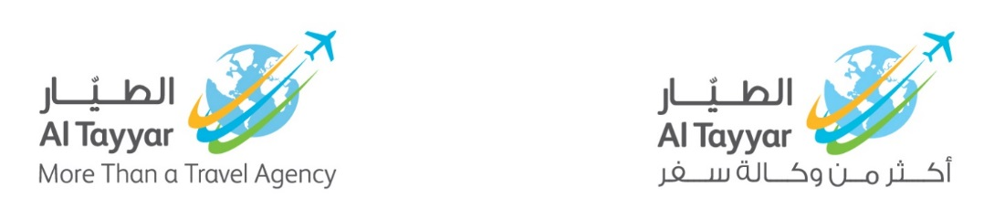

|  |  |  |
| --- | --- | --- |
| **NO** | **OFFICES** | **Ad Address dress** |
| 1 | **RIYADH** | Al Olaya Takhasosi Street, Tel. 011-4633133 Ext.: 3335 / 3334 / 3332, Faks 011 4656049,  Email [visa@altayyargroup.com](mailto:visa@altayyargroup.com) |
| 2 | **AL KHOBAR** | King Faisal Bin Abdulaziz St. Corniche Area, Al Khobar, Tel. 013 – 8495959 Ext. : 3330, Faks 013 – 845858,  Email: [joey.villanueva@altayyargroup.com](mailto:joey.villanueva@altayyargroup.com) |
| 3 | **DAMMAM** | King Saud St. Al Dammam, Tel. 013 / 8356060  Ext. : 107, Faks 013 – 845858,  Email: tours12.ep@altayyargroup.com |
| 4 | **JEDDAH** | Ashour Center, P.O. Box 11688, Jeddah 21463, Tel. 012-6577333       Ext.:286, Faks 012-6578333,  Email: muhammad.iftikhar@altayyargroup.com |
| 5 |  | Ashour Center, P.O. Box 11688, Jeddah 21463, Tel. 012-6577333       Ext.:286, Faks 012-6578333,  Email: [tourism.jed7@altayyargroup.com](mailto:tourism.jed7@altayyargroup.com) |
| 6 | **Al GASSİM** | Omar Ibn Elkhattab  Buridah, Gassim, KSA, Tel. 016 – 3850937, Faks 016 - 3827092  Sultan Alwan-0505431041- sultan.alwan@altayyargoup.com  Adel Mohamed-505431082- Adel.Mohamed@altayyargroup.com  JaiDileep-0539207401-Jaidileep.Mohan@altayyargroup.com |
| 7 | **HAİL** | Mohamed Hamdy-505432016- mohamed.hamdy@altayyargroup.com  Omer Shehab-505431893- sls.mgr.hail@altayyargroup.com |